# Usability Heuristics for QEESI

Good Ok Bad

## **1.Visibility of system status**

*Explanation: What’s going on now in the system?*

The system should always keep users informed about what is going on, through appropriate feedback within reasonable time. (Read full article on [visibility of system status](https://www.nngroup.com/articles/visibility-system-status/).)

1a,1b,1c Good: It indicates the current status using a green background

## 

## 

## 

1d ok: if a score was calculated, there will be a red bar indicating this score is been rated, however, it might look like a warning signal

## 

## **2. Match between system and the real world**

*Explanation: use familiar concepts and words for the users in the systems*

The system should speak the users' language, with words, phrases, and concepts familiar to the user, rather than system-oriented terms. Follow real-world conventions, making information appear in a natural and logical order.

(Read full article on the [match between the system and the real world](https://www.nngroup.com/articles/match-system-real-world/).)

2a Good: using examples in user’s words to explain the symptoms they want to ask

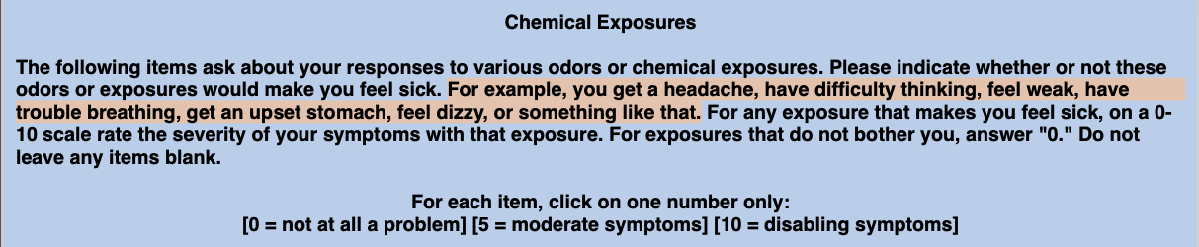

2b Bad: The issue of not having an NA option in the options

## **3. User control and freedom**

*Explanation: there is an option that provides users to correct mistakes*

Users often choose system functions by mistake and will need a clearly marked "emergency exit" to leave the unwanted state without having to go through an extended dialogue. Support undo and redo.  
3a Good: they have a reset button for users to click on

  
 3b Good: Users can tailor their view scale



## 

## **4. Consistency and standards**

*Explanation: use standards if it already exists in other familiar products, or be consistent within the system*

Users should not have to wonder whether different words, situations, or actions mean the same thing. Follow [platform conventions](https://www.nngroup.com/articles/do-interface-standards-stifle-design-creativity/).

4a 4b good: they use two scales, one is 0-10, the other is 0 or 1, to answer different types of questions.

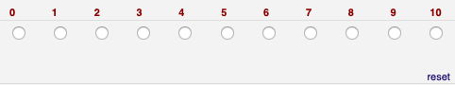  
4c: inconsistent alignments

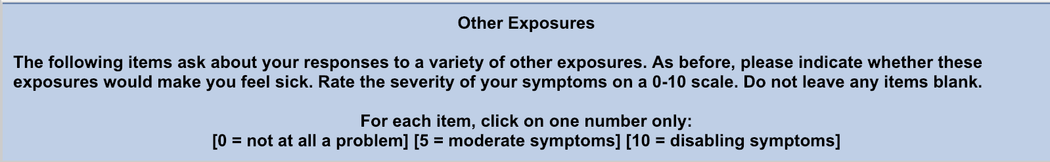

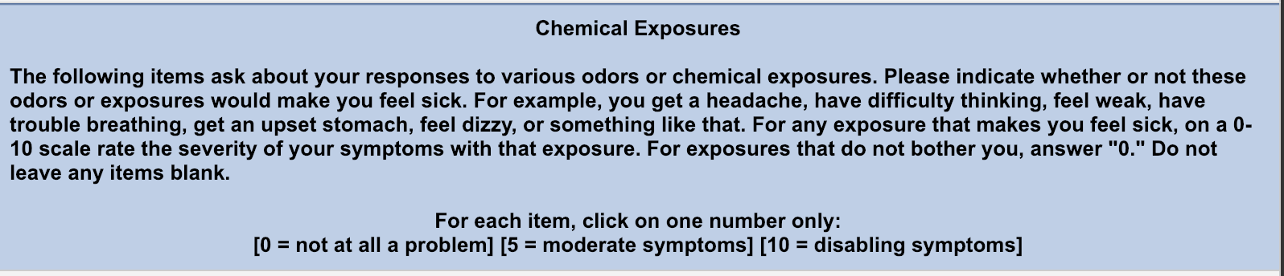  
4d. Inconsistent background color

## 

## 

## **5. Error prevention**

Even better than good error messages is a careful design which prevents a problem from occurring in the first place. Either eliminate error-prone conditions or check for them and present users with a confirmation option before they commit to the action. (Read full article on [preventing user errors](https://www.nngroup.com/articles/slips/).)

5a bad: the error appears after user click submit, it should occur before the submit 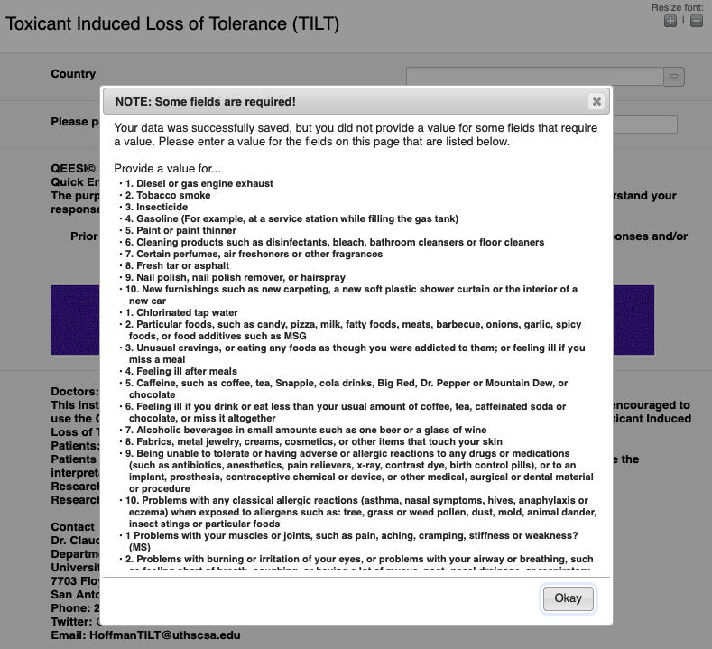

## **6. Recognition rather than recall**

Minimize the user's memory load by making objects, actions, and options visible. The user should not have to remember information from one part of the dialogue to another. Instructions for use of the system should be visible or easily retrievable whenever appropriate. (Read full article on [recognition vs. recall in UX](https://www.nngroup.com/articles/recognition-and-recall/).)  
6a ok: the scale number appears on the top when users are selecting the answers.

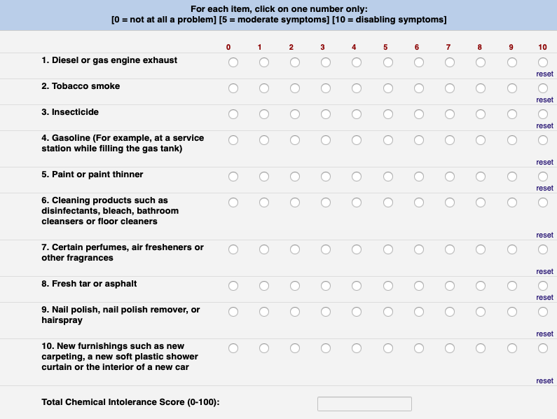

## **7. Flexibility and efficiency of use**

Accelerators — unseen by the novice user — may often speed up the interaction for the expert user such that the system can cater to both inexperienced and experienced users. Allow users to tailor frequent actions.  
bad 7a: when hovering on the link, there is no cursor image, it might be difficult for novice user to know it could click on.

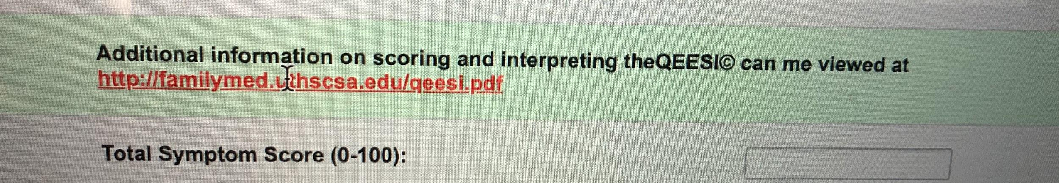  
Good 7b: score auto calculation



Bad 7c: This asks for any additional chemical exposures but it unclear how to write it. For example, should the chemical and score be separated by a comma, period, or space? A better approach may be to have two separate boxes. One for the chemical and one for the score.



## **8. Aesthetic and minimalist design**

Dialogues should not contain information which is irrelevant or rarely needed. Every extra unit of information in a dialogue competes with the relevant units of information and diminishes their relative visibility.

8a bad: The radio buttons are not aligned with the numbers and it might be too small to click on. And the position of the reset button can be improved.

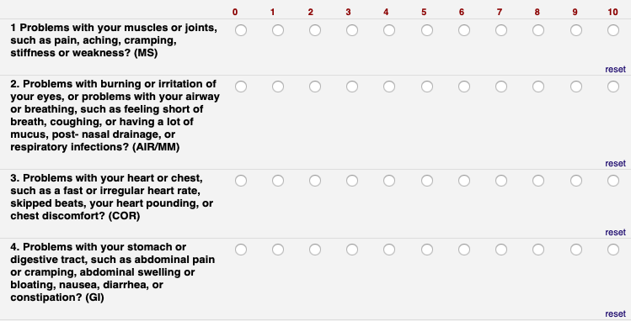

## **9. Help users recognize, diagnose, and recover from errors**

[Error messages](https://www.nngroup.com/articles/error-message-guidelines/) should be expressed in plain language (no codes), precisely indicate the problem, and constructively suggest a solution.

9a Ok: If the user misses input fields, there is a list showing all the unlisted items, but it will disappear after the user clicks on “Okay”

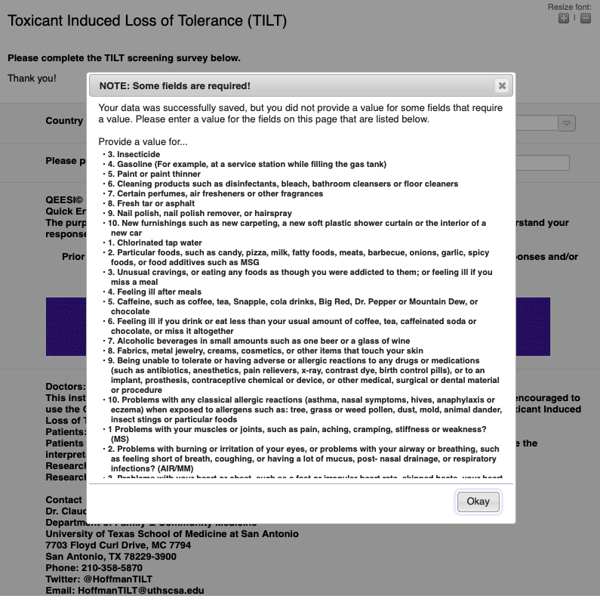  
 5b ok: If the user chooses the options wrong, they can’t recover quickly, there is only a reset button for them to go back.



## **10. Help and documentation**

Even though it is better if the system can be used without documentation, it may be necessary to provide help and documentation. Any such information should be easy to search, focused on the user's task, list concrete steps to be carried out, and not be too large.

10a ok: it does a good job on explaining how to interpret the result, as well as providing additional information link to the website, however, it is unclear what “can me view at...” means

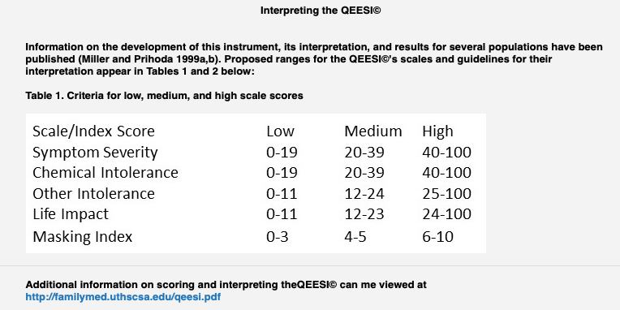

10b bad: the print instruction is unclear. For the Symptom Star on the last page, it suggests users to print it and to draw on it by themselves. But it doesn’t provide an independent form to print. If users print the whole form, it will also print the former pages. If users just print the last page, it doesn’t contain the explanation of these abbreviations.

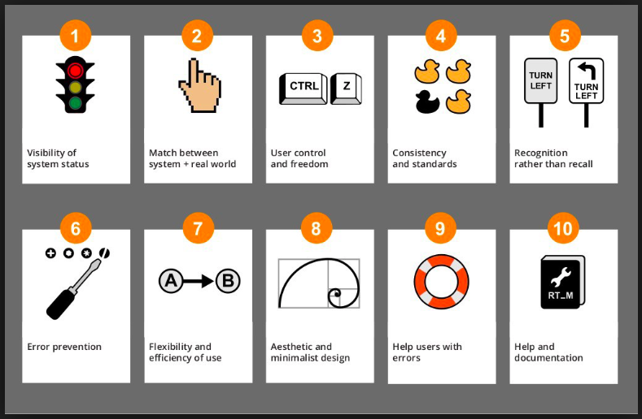

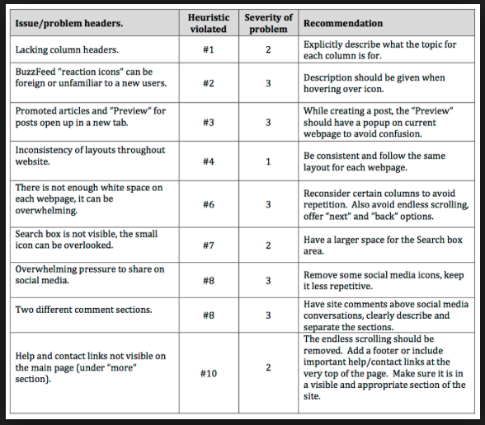

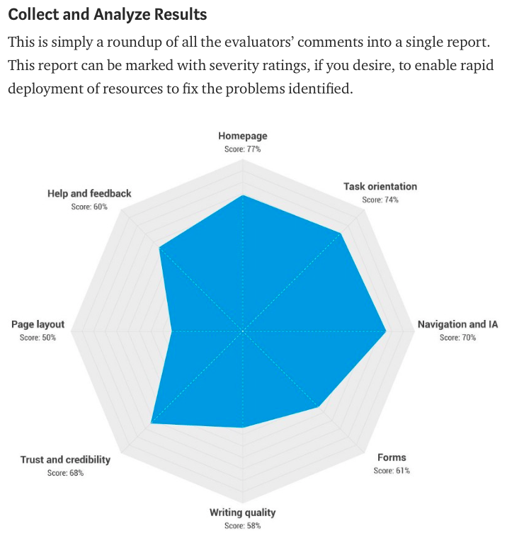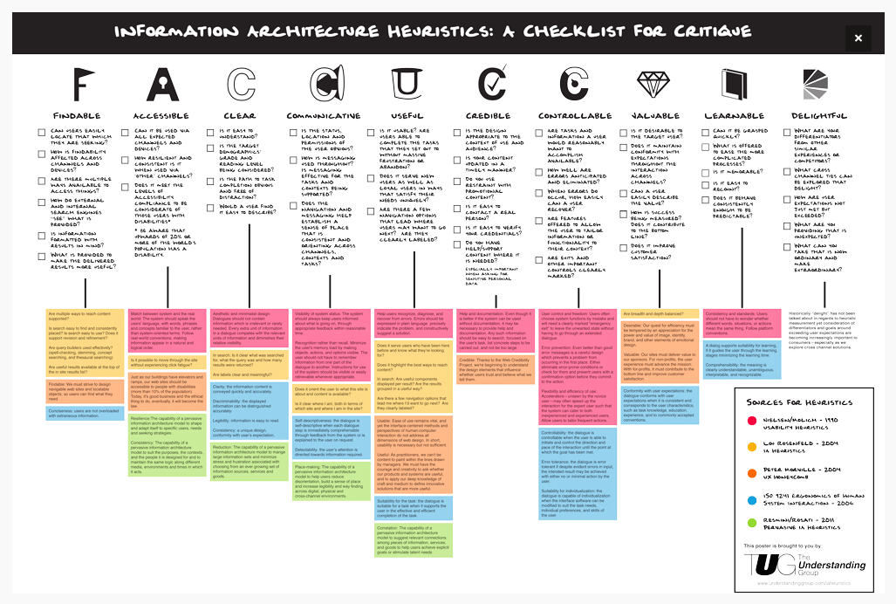

Peidi’s feedback:

1. I found this form in Scoring the QEESI part. I can choose the textbox, but I cannot type anything. I don’t know what’s this for.

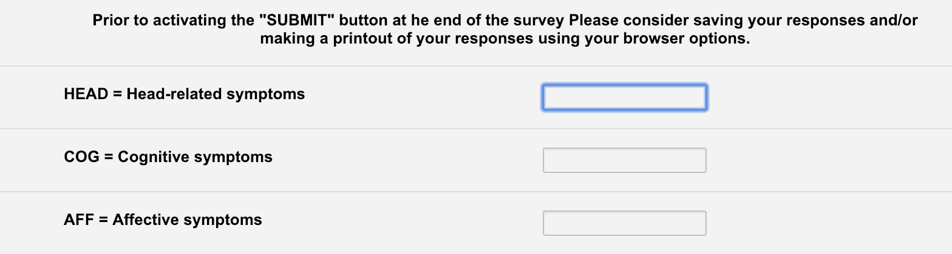

2. For the Symptom Star on the last page, it suggests users to print it and to draw on it by themselves. But it doesn’t provide an independent form to print. If users print the whole form, it will also print the former pages. If users just print the last page, it doesn’t contain the explanation of these abbreviations.

3. We can also consider evaluation of the QUSSEI website, can users quickly understand that and find what they want? How the website, BRSSEI, QUSSEI linked with each other functionally and formatly.

Kramer’s Feedback

1. This asks for any additional chemical exposures but it unclear how to write it. For example, should the chemical and score be separated by a comma, period, or space? A better approach may be to have two separate boxes. One for the chemical and one for the score.
2. The issue of not having an NA option